LINUX PROGRAMMING LAB

Laboratory Manual

III YEAR B.TECH (I - SEM)
(CSE/IT)





Department of Computer Science and Engineering



LINUX PROGRAMMING LAB

Laboratory Manual

III YEAR B.TECH (I - SEM)
(CSE/IT)

Department of Computer Science and Engineering

Document No:  MLRIT/CSE/LAB MANUAL/LP | Date of Issue  12-June-2019  Date of Revision | Faculty name  Mr.Sk.Khaja Shareef  Dr.P.Subhashini  Ms.S Vahini  Verified by  Mr.K.Prabhakar Reddy | Authorized by  HOD  (C.S.E)

LAB CODE

- Students should report to the concerned lab as per the time table.

- Students who turn up late to the labs will in no case be permitted to do the program schedule for the day.

- After completion of the program, certification of the concerned staff in-charge in the observation book is necessary.

- Student should bring a notebook of 100 pages and should enter the readings /observations into the notebook while performing the experiment.

- The record of observations along with the detailed experimental procedure of the experiment in the immediate last session should be submitted and certified staff member in-charge.

- Not more than 3-students in a group are permitted to perform the experiment on the set.

- The group-wise division made in the beginning should be adhered to and no mix up of students among different groups will be permitted.

- The components required pertaining to the experiment should be collected from stores in-charge after duly filling in the requisition form.

- When the experiment is completed, should disconnect the setup made by them, and should return all the components/instruments taken for the purpose.

- Any damage of the equipment or burn-out components will be viewed seriously either by putting penalty or by dismissing the total group of students from the lab for the semester/year.

- Students should be present in the labs for total scheduled duration.

- Students are required to prepare thoroughly to perform the experiment before coming to laboratory.

- Procedure sheets/data sheets provided to the student’s groups should be maintained neatly and to be returned after the experiment.

INDEX

EXPERIMENT NO. | NAME OF THE EXPERIMENT
1 | Study and Practice on various commands like man, passwd, tty, script, clear, date, cal, cp,  mv, ln, rm, unlink, mkdir, rmdir, du, df, mount, umount, find, unmask, ulimit, ps, who, w.
2 | Study and Practice on various commands like cat, tail, head , sort, nl, uniq, grep,  egrep,fgrep, cut, paste, join, tee, pg, comm, cmp, diff, tr, awk, tar, cpio.
3 | a)Write a Shell Program to print all .txt files and .c files.  b)Write a Shell program to move a set of files to a specified directory.  c)Write a Shell program to display all the users who are currently logged in after a  specified time. d) Write a Shell Program to wish the user based on the login time.
4 | a) Simulate cat command. b) Simulate cp command.
5 | a) Simulate head command. b) Simulate tail command.
6 | a) Simulate mv command. b) Simulate nl command.
7 | Write a program to handle the signals like SIGINT, SIGQUIT, SIGFPE
8 | Implement the following IPC forms  a. FIFO  b. PIPE
9 | Implement message queue form of IPC.
10 | Implement shared memory form of IPC.
11 | Write a Socket program to print system date and time (Using TCP/IP).

LINUX PROGRAMMING LAB

Course Overview:
In this course basics of shell programming are dealt. Shell programs to understand the operating environment of Linux are practiced. An exposure to system calls types of process and inter process communication issues are dealt with practical exercises.

Course Objectives:
I. To familiarize basic concepts of shell programming
II. To demonstrate use of system calls
III. To demonstrate Inter process communication

Course Outcomes:

At the end of the course students will be able to:
1. Apply built in commands for file processing.
2. Implement Linux shell scripts.
3. Develop the programs to implement system calls.
4. Apply the core concept of Processes and implement in the Linux Environment by handling
signals.
5. Implement the Inter-Process communication and Client-Server Application techniques in
Linux environment.

WEEK 1: Study and Practice on various commands like man, passwd, tty, script, clear, date, cal, cp, mv, ln, rm, unlink, mkdir, rmdir, du, df, mount, umount, find, unmask,Ulimit, ps, who, w.

Man ual command.
man This is help command, and will explains you about online manual pages you can also use man in conjunction with any command to learn more about that command for example.
Cal command
cal command will print the calander on current month by default. If you want to print calander of august of 1965. That's eightht month of 1965.
cal 8 1965 will print following results.
August 1965
S M Tu W Th F S
1 2 3 4 5 6 7
8 9 10 11 12 13 14
15 16 17 18 19 20 21
22 23 24 25 26 27 28
29 30 31

Clear command
clear command clears the screen and puts cursor at beginning of first line.
Tty command
Tty command will display your terminal. Syntax is
tty options
Options
- -l will print the synchronous line number.
- -s will return only the codes: 0 (a terminal), 1 (not a terminal), 2 (invalid options) (good for scripts)
Mkdir command.
mkdir shekhar will create new directory, i.e. here shekhar directory is created.

Cd command.
cd shekhar will change directory from current directory to directory.
Use pwd to check your current directory and ls to see if shekhar directory is there or not.
You can then use cd shekhar to change the directory to this new directory.

Cp command.
cp command copies a file. If I want to copy a file named oldfile in a current directory to a file named newfile in a current directory.
cp oldfile newfile
If I want to copy oldfile to other directory for example /tmp then
cp oldfile /tmp/newfile. Useful options available with cp are -p and -r . -p options preserves the modification time and permissions, -r recursively copy a directory and its files, duplicating the tree structure.
Mv command.
mv command is used to move a file from one directory to another directory or to rename a file.
Some examples:
- mv oldfile newfile will rename oldfile to newfile.
- mv -i oldfile newfile for confirmation prompt.
- mv -f oldfile newfile will force the rename even if target file exists.
- mv * /usr/bajwa/ will move all the files in current directory to /usr/bajwa directory.
Rm command.
To delete files use rm command.
Options:
- rm oldfile will delete file named oldfile.
- rm -f option will remove write-protected files without prompting.
- rm -r option will delete the entire directory as well as all the subdirectories, very dangerous command.
Rmdir command.
rmdir command will remove directory or directories if a directory is empty.
Options:
- rm -r directory_name will remove all files even if directory is not empty.
- rmdir sandeep is how you use it to remove sandeep directory.
- rmdir -p will remove directories and any parent directories that are empty.
- rmdir -s will suppress standard error messages caused by -p.
Find command.
Find command is a extremely useful command. you can search for any file anywhere using this command provided that file and directory you are searching has read write attributes set to you ,your, group or all. Find descends directory tree beginning at each pathname and finds the files that meet the specified conditions. Here are some examples.
Some Examples:
find $HOME -print will lists all files in your home directory.
find /work -name chapter1 -print will list all files named chapter1 in /work directory.
find / -type d -name 'man*' -print will list all manpage directories.
PS command
ps command is probably the most useful command for systems administrators. It reports information on active processes.
ps options
options.
- -a Lists all processes in system except processes not attached to terminals.
- -e Lists all processes in system.
- -f Lists a full listing.
- -j print process group ID and session ID.
Who command
who command displays information about the current status of system.
who options file
Who as default prints login names of users currently logged in.
Options
- -a use all options.
- -b Report information about last reboot.
- -d report expired processes.
- -H print headings.
- -p report previously spawned processes.
- -u report terminal usage.

passwd - change user password
DESCRIPTION
The passwd command changes passwords for user accounts. A normal user may only change the password for his/her own account, while the superuser may change the password for any account. passwd also changes the account or associated password validity period.
$ passwd
Changing password for ubuntu.
(current) UNIX password:
Enter new UNIX password:
Retype new UNIX password:
passwd: password updated successfully

du command (short for disk usage) is useful command which is used to find disk usage for files & directories. du command when used with various options provides results in many formats.

Disk usage with file/directory sizes in human readable format I.e. in kb, mb etc
$ du -h /home

df COMMAND
df command (short for disk filesystem) is used to show disk utilization for a Linux system.
Some examples are shared below.
1- To display information of device name, total blocks, total disk space, used disk space, available disk space and mount points on a file system.
$df
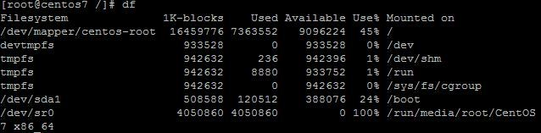

Description: mount
All files accessible in Unix, or a Unix-style system such as Linux, are arranged in one big tree: the file hierarchy, rooted at /. These files can be spread out over several devices. The mount command attaches a filesystem, located on some device or other, to the file tree. Conversely, the umount command will detach it again.
The standard form of the mount command is:
mount -t type device dir
This tells the kernel to attach the filesystem found on device (which is of type type) at the directory dir. The previous contents (if any), owner, and mode of dir become invisible, and as long as this filesystem remains mounted, the pathname dir refers to the root of the filesystem on device.
If only directory or device is given, for example:
mount /dir
then mount looks for a corresponding mountpoint (and then, if not found, for a corresponding device) entry in the /etc/fstab file, and attempts to mount it.

Description: umount

2. Study and practice of various,lp commands like cp,cat,tail,head,sort,nl,unique, grep,cut,paste,join,tee,peg,comm, cmp , diff , tr, awk ,tar , cpio

Cat:
The cat command reads one or more files and prints them to standard output. The operator > can be used to combine multiple files into one. The operator >> can be used to append to an existing file.
The syntax for the cat command is:
cat [options] [files]
option:
-e | $ is printed at the end of each line. This option must be used with -v.
Examples:
- $cat file1 // displays the contents of file1
2. $cat file1 file2 > file3 //concatenates file1 and file2, and writes the results in file3
3. $cat file1 >> file2 //appends a copy of file1 to the end of file2
- Tail:
The tail command displays the last ten lines of the file.
The syntax for the tail command is:
tail [options] [file]
options:
-f | Follow the file as it grows.
-r | Displays the lines in the reverse order.
-n[k] | Displays the file at the nth item from the end of the file.
+n[k] | Displays the file at the nth item from the beginning of the file.
Examples:
1. By default, tail will print the last 10 lines of its input to the standard output. Withcommand line options the number of lines printed and the printing units (lines, blocks or bytes) may be changed. The following example shows the last 20 lines of filename:
$tail -n 20 filename
2. This example shows all lines of filename from the second line onwards:
$tail -n +2 filename

Head:
The head command displays the first ten lines of a file.
The syntax for head command is:
$head [options] <filename>
By default, head will print the first 10 lines of its input to the standard output. The number of lines printed may be changed with a command line option. The following example shows the first 20 lines of filename:
$head -n 20 filename
This displays the first 5 lines of all files starting with foo:
$head -n 5 foo*
Sort : Sorting is the ordering of data in ascending or descending sequence. The sort command orders a file. By default sort reorders lines in ASCII collating sequence_ white space first, then numerals, uppercase letters and finally lowercase letters.
1.Sort by lines: The easiest sort arranges data by lines. Starting at the beginning of the line, it compares the first character in one line with the first character in another line.
Syntax: $ sort filename
2.Sort by fields: in general a field is the smallest unit of data. When a field sort is required we need to define which fields are to be used for the sort.
Syntax: $ sort –t ” “ –k2 filename
Here we use –k option to sort on the specified field. The delimiter option (-t) specifies an alternate delimiter.
3.Reverse order: To order the data from largest to smallest,we specify reverse order(-r).
Syntax: $ sort –t : -k2.3 -r filename
Here it sorting the data based on 3rd character of the second field in descending order.
options:
-tchar - Use delimiter char to identify fields
-k n - Sorts on nth field
-k m,n - Starts sort on mth field and ends sort on nth
Field
-k m.n - Starts sort on nth column of mth field
-u - Removes repeated lines
-n - Sorts numerically
-r - Reverses sort order

Nl:

Nl Is A Unix Utility For Numbering Lines, Either From A File Or From Standard Input, Reproducing Output On Standard Output.
options:
• s – separator- number and data is separated with separator
• w - width
Eg: $nl filename
$nl –s: file1
$nl –w20 –s: file1
uniq:
This command displays uniq lines of the given files. That is, if successive lines of a file are same then they will be removed. This can be used to remove successive empty lines in a given file.
The syntax of usage of this command is given as:
$uniq[OPTIONS] INPUT [OUTPUT]
options:
-c Prefix lines by their occurrences
-d Only print repeated lines
-D Print all duplicate lines
-u Only print unique lines
Example:
$ uniq testfile (or uniq –u testfile)
$ sort f1 | uniq

Grep: (Global Regular Expression) Searching for a pattern

UNIX has a special family of commands for handling search requirements, and the principal member of this family is the grep command. grep scans its input for a pattern and displays lines containing the pattern, the line numbers or filenames where the pattern occurs.
Syntax: grep options pattern filename(s)
Grep searches for pattern in one or more files ,or the standard input if no filename is specified. The first argument is the pattern and the remaining arguments are filenames.
Eg: $ grep “sales” employee
It displays the lines containing the string sales from the file employee.
Grep is also used with multiple filenames.It displays the filenames along with the ouput.
Eg: $ grep director emp1 emp2
$ grep “sales director” emp1 emp2
Here quoting is not necessary.when we use pattern with multiple words then we have to use quoting.
options:
option significance
-I - Ignores case for matching
-v - Doesn’t display lines matching expression
-n - Displays line numbers along with lines
-c - Display count of number of occurrences
-l - Displays list of filenames only

The fgrep and egrep command:
The fgrep and egrep command are advanced pattern matching command. The fgrep command doesn’t use any meta character for its searched pattern. The primary advantage of fgrep is it can also serch two or more than two strings simultaneously. The fgrep command can be used like this:
$fgrep ‘good bad great’ userfile
Here a single quote is used to mark three strings as one argument. Here we are going to search three different strings good, bad, and great. The egrep command is used to search this in a more compact form than fgrep command:
$egrep ‘good | bad | great’ userfile
The egrep uses an or ( | ) operator to achieve this. Therefore egrep command is more compact and more versatile than fgrep. Another achievement of egrep is that we can make groups of different patterns. If we use | as operator.
$egrep ‘sunil | rohan gavasker ‘ players
Here sunil is first pattern and everything to the right is considered as second pattern.
If we want to search both sunil gavasker and rohan gavasker use this:
$egrep ‘(sunil | rohan)‘ players
$egrep -f pat.lst file1 –this option is for using files instead of directly specifying different patterns.
$fgrep -f pat.lst file1

Cut command:
By using this command, we can extract the required columns or fields from the file.
This command extracts the fields based on either character position or on field delimeters position.
Options:
-c - Used to extracts the fields based on character position or columns.
-f - Used to extracts the required fields based on field delimeters.
(By default field delimeter is tab)
-d - Used to define our own delimeters.

Eg:
cut –f1,3 filename
This displays 1st and 3rd words of each line of the given file. Between word to word TAB
should available.
cut –d”:” -f1,3 filename
This displays user name ,UID of each legal user of the machine. Herewith –d option
we are specifying that : is the field separator between word to word.
The same result is given by the following command cut -d”:” -f3,1 /etc/passwd.
cut -d”:” -f1-3 filename
This displays 1st word to 3rd word from each line of the given file.
cut -f “:” –f3- filename
This displays 3rd word to till last word of each line of the given file.
cut -f “:” –f-3 filename
This displays 1st word to till 3rd word of each line of the given file.
cut -c3-5 filename
This displays 3rd character to 5th character of each line in the given file.

Paste command:
This command is used to create new files by gluying together fields or columns From two or more files.

Syntax: paste filename1 filename2

Consider the following eample
$cat indo.lst
20032
20034
20121

$cat name.lst
H.D Rao
M.G.V Murthy
P.K.Krishna

$paste indo.lst name.lst >info.lst

The result of paste command is
$cat info.lst
20032 H.D Rao
20034 M.G.V Murthy
20121 P.K.Krishna

$paste –d : indo.lst name.lst
This command combines the data in the files by using : symbol in between the fields of two files.

Join command:

Join lines of two files based on a common field. You can join two files based on a common field, that you can specify using field.
Syntax: $ join -t':' -1 N -2 N file1 file2
- -t’:’ – : is the field separator
- -1 N : Nth field in 1st file
- -2 N : Nth field in 2nd file
- file1 file2 : files that should be joined
In this example, let us combine employee.txt and bonus.txt files using the common employee number field.
$ cat employee.txt
100 Emma Thomas
200 Alex Jason
300 Madison Randy
400 Sanjay Gupta
500 Nisha Singh

$ cat bonus.txt
$5,000 100
$5,500 200
$6,000 300
$7,000 400
$9,500 500

$ join -1 1 -2 2 employee.txt bonus.txt
100 Emma Thomas $5,000
200 Alex Jason $5,500
300 Madison Randy $6,000
400 Sanjay Gupta $7,000
500 Nisha Singh $9,500
Pg command:
pg is a terminal pager program on Unix for viewing text files. It can also be used to page through the output of a command via a pipe. pg uses an interface similar to vi.
Syntax: $pg filename

comm command:
comm - compare two sorted files line by line. The comm command in the Unix family of computer operating systems is a utility that is used to compare two files for common and distinct lines
comm reads two files as input, regarded as lines of text. comm outputs one file, which contains three columns. This functionally is similar to diff.Columns are typically distinguished with the <tab> character
Syntax: comm [OPTION]... FILE1 FILE2
With no options, produce three-column output. Column one contains lines unique to FILE1, column two contains lines unique to FILE2, and column three contains lines common to both files.
Col1- suppress lines unique to FILE1
Col2 - suppress lines unique to FILE2
Col3- suppress lines that appear in both files
eg: $comm-1 file1 file2 //It displays only 2nd and 3rd columns
Cmp command:
cmp is a command line utility for computer systems that use Unix. It compares two files of any type and writes the results to the standard output. By default, cmp is silent if the files are the same; if they differ, the byte and line number at which the first difference occurred is reported.
Syntax : cmp [-c] [-i N] [-l] [-s] [-v] firstfile secondfile
Options:
-c | Output differing bytes as characters.
-l | Write the byte number (decimal) and the differing bytes (octal) for each difference.
-s | Write nothing for differing files; return exit statuses only.
-v | Output version info.
Examples
$cmp file1.txt file2.txt
Compares file1 to file2 and outputs results. Below is example of how these results may look.
$file.txt file2.txt differ: char 1011, line 112
diff command:
This command is used to display file differences. It also tells you which lines in one file have to be changed to make two files identical.
Syntax: $ diff file1 file2
diff uses certain special symbols and instructions to indicate the changes that are required to make two files identical. Each instruction uses an address combined with an action that is applied to the first file.
The instruction
1. 7a8 means appending line after line 7, which become line8 in the second file.
2. 3c3 change line 3 which remains 3 line after the change.
3. 5,7c5,7 changes 3 lines.

tr command: (translate or transliterate)
When executed, the program reads from the standard input and writes to the standard output. It takes as parameters two sets of characters, and replaces occurrences of the characters in the first set with the corresponding elements from the other set.
Syntax: tr options expression1 expression2 < standard input

Eg:1.$tr 'abcd' 'jkmn'
maps 'a' to 'j', 'b' to 'k', 'c' to 'm', and 'd' to 'n'.
Sets of characters may be abbreviated by using character ranges. The previous example could be written:
2.$tr 'a-d' 'jkmn'
3. $ tr ‘a-z’ ‘A-Z’ < file1
Options:
-d -- delete the specified characters
$ tr –d ‘ad’ < file1
-c – delete all the characters except specified character.
$ tr –cd ‘ad’ < file1

Backup utilities:

Tar command:
In computing, tar (derived from tape archive) is both a file format (in the form of a type of archive bitstream) and the name of a program used to handle such files. It is now commonly used to collect many files into one larger file for distribution orarchiving, while preserving file system information such as user and group permissions, dates, and directory structures.
Options:
c | Create. Writing begins at the beginning of the tarfile, instead of at the end.
r - | Replace. The named files are written at the end of the tarfile.
t - | Table of Contents. The names of the specified files are listed each time they occur in the tar file
x - | Extract or restore. The named file s are extracted from the tarfile and written to the directory specified in the tarfile, relative to the current directory
f - | File. Use the tarfile argument as the name of the tarfile.
v - | Verbose. Shows number of blocks used by each file.
Eg:
$tar – cvf archive.tar f1 f2 f3 //It creates an archive which combine these 3 files
$tar –xvf archive.tar //To display all files in the archive
$tar –tvf archive.tar //properties of all files

Tee command:
In computing, tee is a command which displays or pipes the output of a command and copies it into a file or a variable. It is primarily used in conjunction withpipes.
tee is normally used to split the output of a program so that it can be seen on the display and also be saved in a file. The command can also be used to capture intermediate output before the data is altered by another command or program. The tee command reads standard input, then writes its content tostandard output and simultaneously copies it into the specified file(s) or variables. The syntax differs depending on the command's implementation
eg: $cat filename |tee filename2 //It copis the output of cat command into filename2
$ cat filename | tee –a filename2 //It appends the output of cat command to the end of filename2

Cpio command:
This command (copy input_output) copies files to and from a backup Device. It uses standard input to take the list of file names. It then copies them with their contents and headers to the standard output which can be redirected to a file or device.This means that cpio can be used with redirection and piping.
cpio uses two key options ,-o(output) and –i(input),either of which (but not both) must be there in the command line.All other options have to be used with either of these key options.
Syntax: cpio options filename
Example:
1. $ls | cpio –oF sample //o for creating file, F for specifying the name of the file
2. $cpio –iF sample //i for extracting data from file.
3. $cpio –itF sample //t for displaying contents

3. a)Write a Shell Program to print all .txt files and .c files.

echo enter the directory path
read path
find $path -iname "*.txt"
find $path -name "*.c"
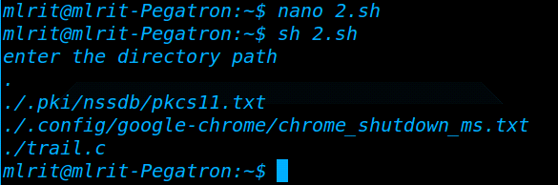

week-3(b)

shell program to print all users logged in a specific time

echo enter time
read sh
echo users who logged at $sh are:
who|while read user term dt; do
t=$(date -d "$dt" +%H)
if [ $sh -eq $t ]; then
echo $user
fi
done
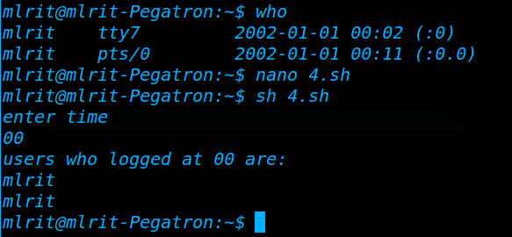

week-3(c)

shell program to move file to directory

echo enter source directory
read spath
echo enter the file pattern
read fpattern
echo enter destination directory
read ddest
find $spath -name $fpattern -exec mv {} $ddest/ \;

week-3(d)

Shell program to wish the user

h=`date +%H`
if [ $h -lt 12 ]; then
echo Hi $USER good mrng
elif [ $h -lt 18 ]; then
echo Hi $USER good afternoon
else
echo Hi $USER good eveng
fi

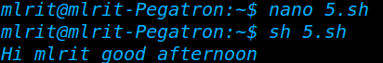

4.a)Simulate cat command
#include<stdio.h>
#include<sys/types.h>
#include<stdlib.h>
#include<fcntl.h>
#include<sys/stat.h>
int main(int argc,char * argv[])
{
int fd,n;
char buff[1024];
if(argc!=2)
printf("Enter correct argumenty :");
if((fd=open(argv[1],4))<0)
{
printf("error");
return 0;
}
while((n=read(fd,buff,sizeof(buff)))>0)
write(1,buff,n);
}

week-4(b)
Simulate cp command
#include<syscall.h>
#include<stdio.h>
#include<stdlib.h>
#include<fcntl.h>
#define BUFSIZE 1024
char buf[BUFSIZE];
int main(int argc,char* argv[])
{
int src,dst,amount;
if(argc!=3)
{
printf("Usage:cp<src><dst>/n");
Return 1;
}
src=open(argv[1],O_RDONLY);
if(src==-1)
{
printf("Unable to open %s/n",argv[1]);
return 1;
}
open(argv[2],0644);
dst=open(argv[2],O_WRONLY);
if(dst==-1)
{
printf("Unable to create %s/n",argv[2]);
return 1;
}
while((amount=read(src,buf,BUFSIZE))>0)
{
write(dst,buf,amount);
printf("Data copied successfully/n");
}
close(src);
close(dst);
return 0;
}

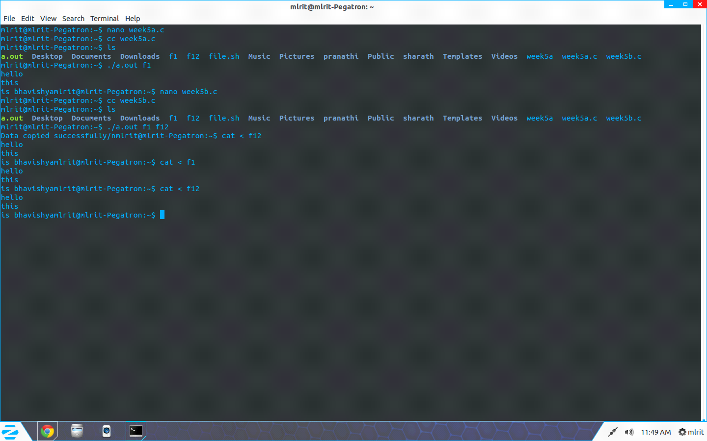

5.a)SIMULATE HEAD COMMAND
#include<stdlib.h>
#include<fcntl.h>
#include<sys/types.h>
#include <stdio.h>
#include<sys/stat.h>
int main(int argc, char * argv[])
{
FILE *fp;
char *line = NULL;
int len = 0;
int cnt = 0;
if( argc < 3)
{
printf("Insufficient Arguments");
return -1;
}
fp = fopen(argv[1],"r");
if( fp == NULL )
{
printf(" %s file can not be opened !!! ",argv[1]);
return 1;
}
while (getline(&line, &len, fp) != -1)
{
cnt++;
if ( cnt > atoi(argv[2]) )
break;
printf("%s",line); fflush(stdout);
}
fclose(fp);
return 0; }
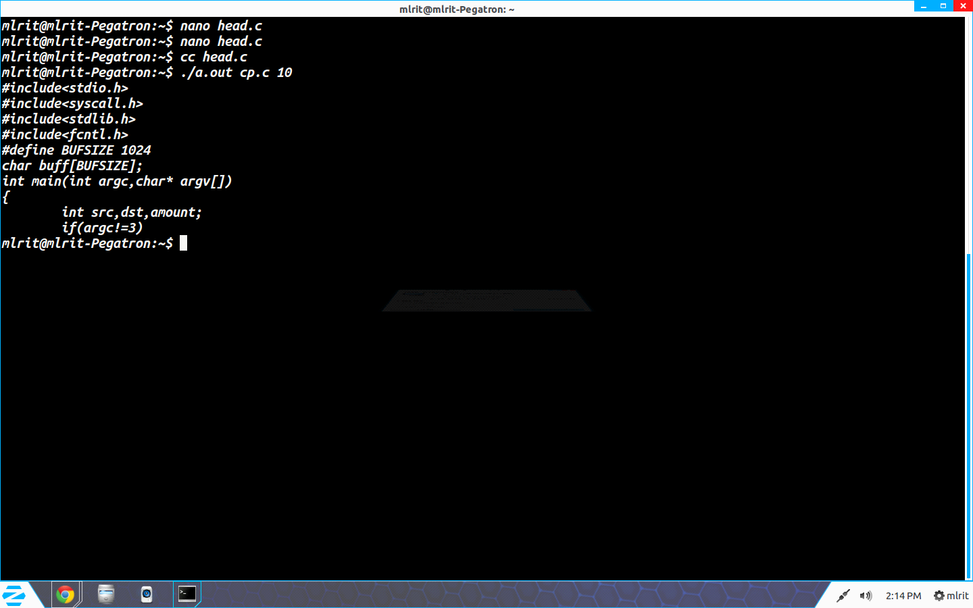

5.b)Simulate Tail command

#include <stdio.h>
#include<stdlib.h>
int main(int argc, char * argv[])
{
FILE *fp,*fp1; // file pointer
char *line = NULL,*l=NULL;
int len = 0,k=0;
int cnt = 0;
int a;
if( argc < 2)
{
printf("Insufficient Arguments!!!\n");
return -1;
}
fp = fopen(argv[1],"r");
// checking for file is exist or not
if( fp == NULL )
{
printf("\n%s file can not be opened !!!\n",argv[1]);
return 1;
}
// read lines from file one by one
while(getline(&line, &len, fp) != -1)
{
cnt++;
}
a=cnt-atoi(argv[2]);
cnt=0;
fp1 = fopen(argv[1],"r");
while(getline(&line, &len, fp1) != -1)
{
cnt++;
if(cnt>=a)
{
printf("%s",line);
}
fflush(stdout);

}
// close file
fclose(fp);
return 0;
}

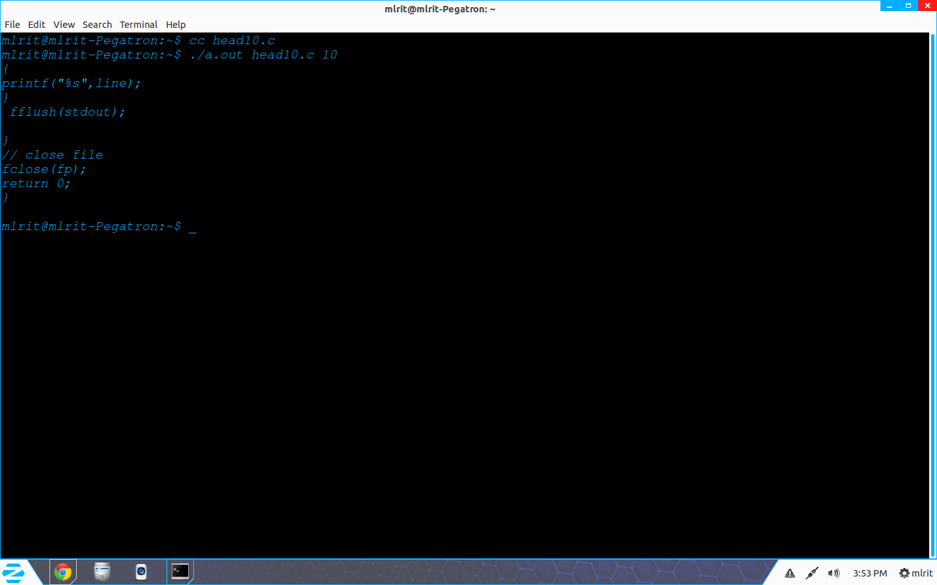

6.a)simulate mv command..

#include<stdio.h>
#include<fcntl.h>
#include<sys/types.h>
#include<stdlib.h>
int main(int argc,char *argv[])
{
char buff[512];
int f1,f2,n;
if(argc!=3)
{
printf("USAGE %s FROM TO : ",argv[0]);
return 0;
}
if((f1=open(argv[1],O_RDONLY))<0)
{
printf("ERROR IN OPENING");
}
if((f2=creat(argv[2],0644))<0)
{
printf("ERROR IN CREATING");
}
while((n=read(f1,buff,sizeof(buff)))>0)
{
if((write(f2,buff,n))<n)
{
printf("WRITE ERROR");
}
}
close(f2);
remove(argv[1]);
}
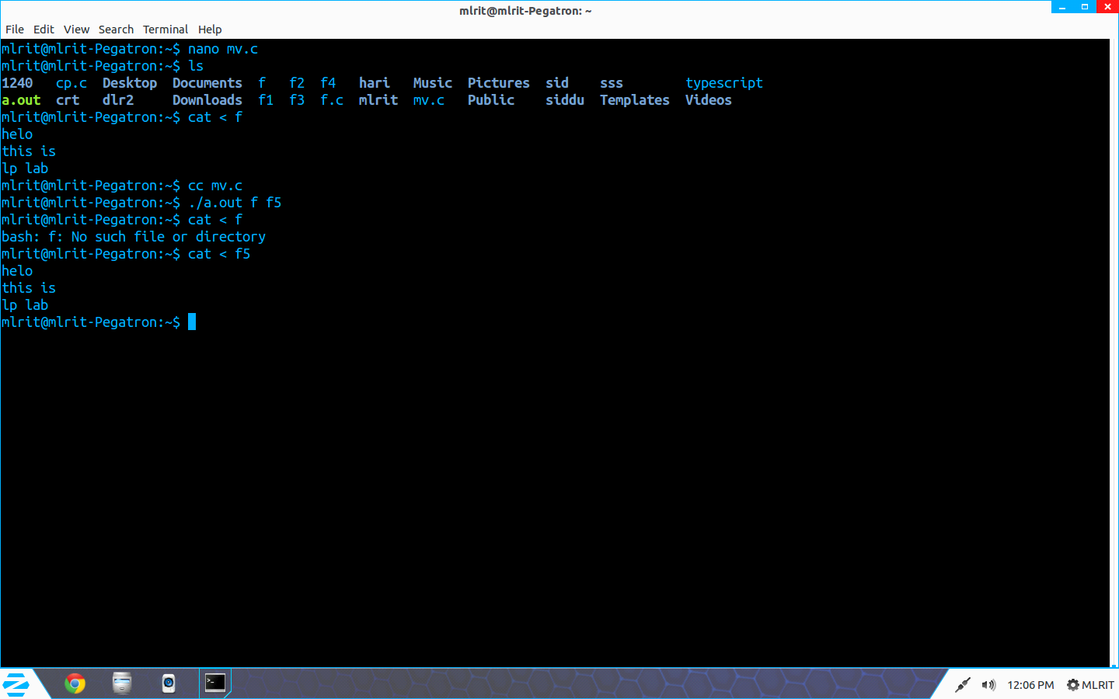

week-6(b)
Simulate NL command
#include <stdio.h>
#include <sys/types.h>
#include <stdlib.h>
#include <fcntl.h>
#include <sys/stat.h>
int main(int argc, char * argv[])
{
FILE * fp;
char * line = NULL;
int len = 0; int cnt = 0;
fp = fopen(argv[1],"r");
if( fp == NULL )
{
printf("\n%s file can not be opened !!!\n",argv[1]);
return 1;
}
while (getline(&line, &len, fp) != -1)
{
cnt++;
printf("%d %s",cnt,line); fflush(stdout);
}
fclose(fp);
return 0; }

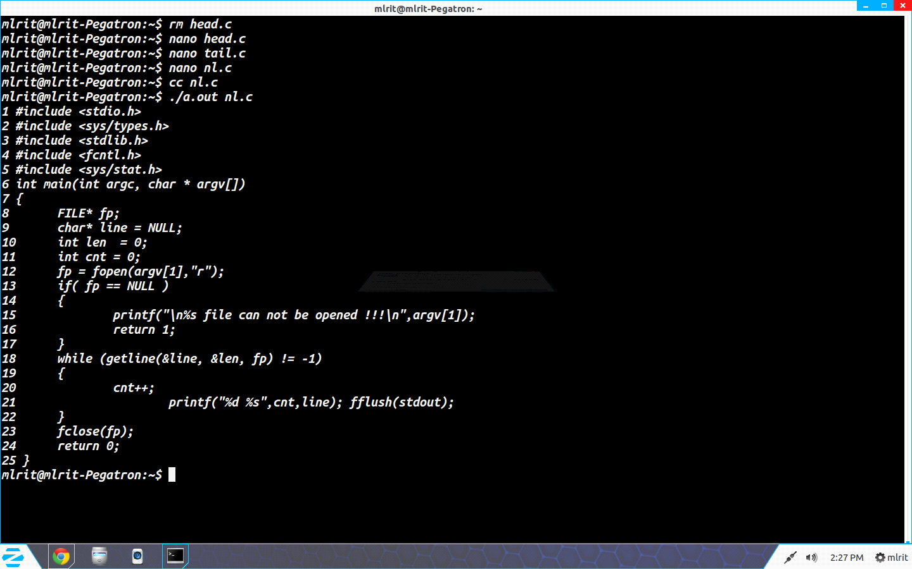

7. Write a program to handle the signals like SIGINT, SIGQUIT, SIGFPE.
SIGINT
#include<stdio.h>
#include<signal.h>
#include<unistd.h>
void sig_handler(int signo)
{
if (signo == SIGINT)
printf("received SIGINT\n");
}
int main(void)
{
if (signal(SIGINT, sig_handler) == SIG_ERR)
printf("\ncan't catch SIGINT\n");
// A long long wait so that we can easily issue a signal to this process
while(1)
sleep(1);
return 0;
}
terminate the process using Ctrl+C
O/P: received SIGINT
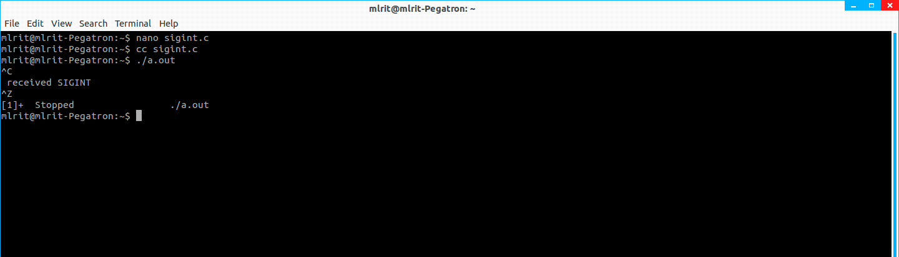
SIGQUIT
#include<stdio.h>
#include<signal.h>
#include<unistd.h>

void sig_handler(int signo)
{
if (signo == SIGQUIT)
printf("received SIGQUIT\n");
}
int main(void)
{
if (signal(SIGQUIT, sig_handler) == SIG_ERR)
printf("\ncan't catch SIGQUIT\n");
// A long long wait so that we can easily issue a signal to this process
while(1)
sleep(1);
return 0;
}
SIGQUIT ctrl-\
O/P:- received SIGQUIT
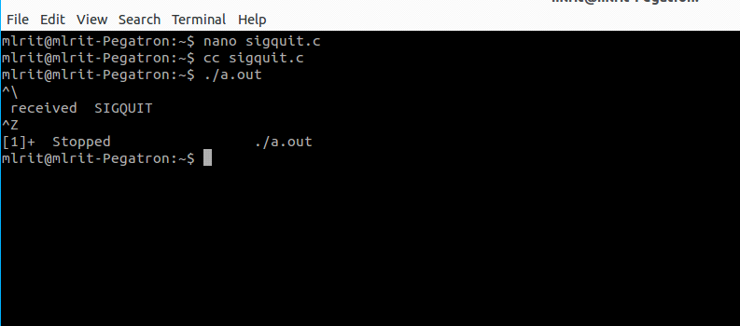

SIGFPE

#include <unistd.h>
#include <signal.h>
#include <stdio.h>
#include <stdlib.h>
static void sig_fpe(int signo);
int main()
{
int pid;
if(signal(SIGFPE, sig_fpe) == SIG_ERR)
printf("Signal error\n");
pid = 10;
pid = pid / 0;
exit(0);
}
static void sig_fpe(int signo)
{
if(signo == SIGFPE)
{
printf("SIGFPE signal catch\n");
}
}

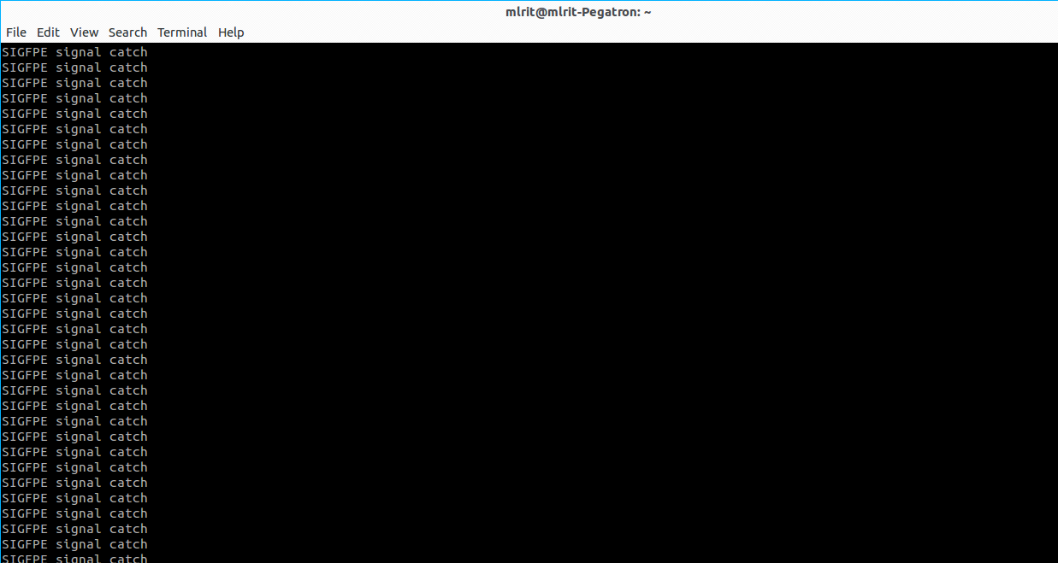

8. Implement the following IPC forms
a. FIFO
b. PIPE

8b)
#include<stdio.h>
#include<stdlib.h>
#include<sys/types.h>
#include<unistd.h>
main()
{
int pfds[2];
char buf[30];
if(pipe(pfds) == -1)
{
perror("Pipe is not created");
exit(1);
}
if(!fork())
{
printf("CHILD: Writing to the pipe\n");
close(pfds[0]);
write(pfds[1],"Hello World, I am child",23);
printf("CHILD:Exiting");
exit(0);
}
else
{
printf("PARENT:reading from the pipe\n");
close(pfds[1]);
read(pfds[0],buf,23);
printf("PARENT:Received Data is :%s",buf);
}
}
INPUT: cc prog20.c
./a.out
OUTPUT:
CHILD: Writing to the pipe
CHILD:Exiting
PARENT:reading from the pipe
PARENT:Received Data is : Hello World, I am child

8 a. FIFO

// C program to implement one side of FIFO
// This side writes first, then reads
#include <stdio.h>
#include <string.h>
#include <fcntl.h>
#include <sys/stat.h>
#include <sys/types.h>
#include <unistd.h>

int main()
{ int fd;
// FIFO file path
char * myfifo = "/tmp/myfifo";
// Creating the named file(FIFO)
// mkfifo(<pathname>, <permission>)
mkfifo(myfifo, 0666);
char arr1[80], arr2[80];
while (1)
{
// Open FIFO for write only
fd = open(myfifo, O_WRONLY);

// Take an input arr2ing from user.
// 80 is maximum length
fgets(arr2, 80, stdin);
// Write the input arr2ing on FIFO
// and close it
write(fd, arr2, strlen(arr2)+1);
close(fd);

// Open FIFO for Read only
fd = open(myfifo, O_RDONLY);
// Read from FIFO
read(fd, arr1, sizeof(arr1));
// Print the read message
printf("User2: %s\n", arr1);
close(fd);
}
return 0;
}

// C program to implement one side of FIFO
// This side reads first, then reads
#include <stdio.h>
#include <string.h>
#include <fcntl.h>
#include <sys/stat.h>
#include <sys/types.h>
#include <unistd.h>

int main()
{
int fd1;

// FIFO file path
char * myfifo = "/tmp/myfifo";

// Creating the named file(FIFO)
// mkfifo(<pathname>,<permission>)
mkfifo(myfifo, 0666);

char str1[80], str2[80];
while (1)
{
// First open in read only and read
fd1 = open(myfifo,O_RDONLY);
read(fd1, str1, 80);

// Print the read string and close
printf("User1: %s\n", str1);
close(fd1);

// Now open in write mode and write
// string taken from user.
fd1 = open(myfifo,O_WRONLY);
fgets(str2, 80, stdin);
write(fd1, str2, strlen(str2)+1);
close(fd1);
}
return 0;
}

Output: Run the two programs simultaneously on two terminals.

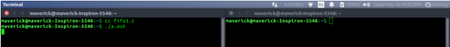
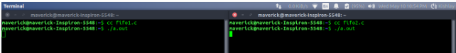

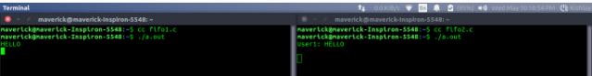
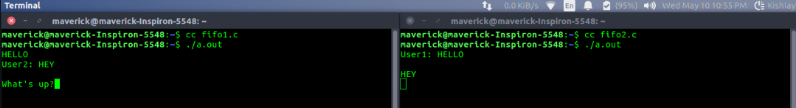

9. Implement message queue form of IPC.

// C Program for Message Queue (Writer Process)
#include <stdio.h>
#include <sys/ipc.h>
#include <sys/msg.h>

// structure for message queue
struct mesg_buffer {
long mesg_type;
char mesg_text[100];
} message;

int main()
{
key_t key;
int msgid;

// ftok to generate unique key
key = ftok("progfile", 65);

// msgget creates a message queue
// and returns identifier
msgid = msgget(key, 0666 | IPC_CREAT);
message.mesg_type = 1;

printf("Write Data : ");
gets(message.mesg_text);

// msgsnd to send message
msgsnd(msgid, &message, sizeof(message), 0);

// display the message
printf("Data send is : %s \n", message.mesg_text);

return 0;
}

// C Program for Message Queue (Reader Process)
#include <stdio.h>
#include <sys/ipc.h>
#include <sys/msg.h>

// structure for message queue
struct mesg_buffer {
long mesg_type;
char mesg_text[100];
} message;

int main()
{
key_t key;
int msgid;

// ftok to generate unique key
key = ftok("progfile", 65);

// msgget creates a message queue
// and returns identifier
msgid = msgget(key, 0666 | IPC_CREAT);

// msgrcv to receive message
msgrcv(msgid, &message, sizeof(message), 1, 0);

// display the message
printf("Data Received is : %s \n", message.mesg_text);

// to destroy the message queue
msgctl(msgid, IPC_RMID, NULL);

return 0;
}

OUTPUT:-
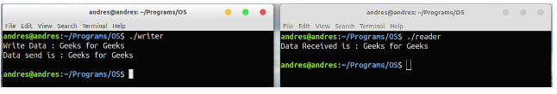

10) Implement shared memory form of IPC.
SHARED MEMORY FOR WRITER PROCESS
#include <iostream>
#include <sys/ipc.h>
#include <sys/shm.h>
#include <stdio.h>
using namespace std;
int main()
{ // ftok to generate unique key
key_t key = ftok("shmfile",65);
// shmget returns an identifier in shmid
int shmid = shmget(key,1024,0666|IPC_CREAT);
// shmat to attach to shared memory
char *str = (char*) shmat(shmid,(void*)0,0);
Prinf("Write Data : ");
gets(str);
printf("Data written in memory: %s\n",str);
//detach from shared memory
shmdt(str);
return 0; }

SHARED MEMORY FOR READER PROCESS
#include <iostream>
#include <sys/ipc.h>
#include <sys/shm.h>
#include <stdio.h>
using namespace std;
int main()
{ // ftok to generate unique key
key_t key = ftok("shmfile",65);
// shmget returns an identifier in shmid
int shmid = shmget(key,1024,0666|IPC_CREAT);
// shmat to attach to shared memory
char *str = (char*) shmat(shmid,(void*)0,0);
printf("Data read from memory: %s\n",str);
//detach from shared memory
shmdt(str);
// destroy the shared memory
shmctl(shmid,IPC_RMID,NULL);
return 0; }


11) Write a Socket program to print system date and time (Using TCP/IP).
// Server side C/C++ program to demonstrate Socket programming
#include <unistd.h>
#include <stdio.h>
#include <sys/socket.h>
#include <stdlib.h>
#include <netinet/in.h>
#include <string.h>
#define PORT 8080
int main(int argc, char const *argv[])
{ int server_fd, new_socket, valread;
struct sockaddr_in address;
int opt = 1;
int addrlen = sizeof(address);
char buffer[1024] = {0};
char *hello = "Hello from server";
// Creating socket file descriptor
if ((server_fd = socket(AF_INET, SOCK_STREAM, 0)) == 0)
{
perror("socket failed");
exit(EXIT_FAILURE);
}
// Forcefully attaching socket to the port 8080
if (setsockopt(server_fd, SOL_SOCKET, SO_REUSEADDR | SO_REUSEPORT, &opt, sizeof(opt)))
{
perror("setsockopt");
exit(EXIT_FAILURE);
}
address.sin_family = AF_INET;
address.sin_addr.s_addr = INADDR_ANY;
address.sin_port = htons( PORT );
// Forcefully attaching socket to the port 8080
if (bind(server_fd, (struct sockaddr *)&address, sizeof(address))<0)
{
perror("bind failed");
exit(EXIT_FAILURE);
}
if (listen(server_fd, 3) < 0)
{
perror("listen");
exit(EXIT_FAILURE);
}
if ((new_socket = accept(server_fd, (struct sockaddr *)&address,(socklen_t*)&addrlen))<0)
{
perror("accept");
exit(EXIT_FAILURE);
}
valread = read( new_socket , buffer, 1024);
printf("%s\n",buffer );
send(new_socket , hello , strlen(hello) , 0 );
printf("Hello message sent\n");
return 0;
}

// Client side C/C++ program to demonstrate Socket programming
#include <stdio.h>
#include <sys/socket.h>
#include <arpa/inet.h>
#include <unistd.h>
#include <string.h>
#define PORT 8080

int main(int argc, char const *argv[])
{
int sock = 0, valread;
struct sockaddr_in serv_addr;
char *hello = "Hello from client";
char buffer[1024] = {0};
if ((sock = socket(AF_INET, SOCK_STREAM, 0)) < 0)
{
printf("\n Socket creation error \n");
return -1;
}

serv_addr.sin_family = AF_INET;
serv_addr.sin_port = htons(PORT);

// Convert IPv4 and IPv6 addresses from text to binary form
if(inet_pton(AF_INET, "127.0.0.1", &serv_addr.sin_addr)<=0)
{
printf("\nInvalid address/ Address not supported \n");
return -1;
}

if (connect(sock, (struct sockaddr *)&serv_addr, sizeof(serv_addr)) < 0)
{
printf("\nConnection Failed \n");
return -1;
}
send(sock , hello , strlen(hello) , 0 );
printf("Hello message sent\n");
valread = read( sock , buffer, 1024);
printf("%s\n",buffer );
return 0;
}

Compiling:
gcc client.c -o client
gcc server.c -o server
Output:
Client:Hello message sent
Hello from server
Server:Hello from client
Hello message sent

